- Set the base on the ground 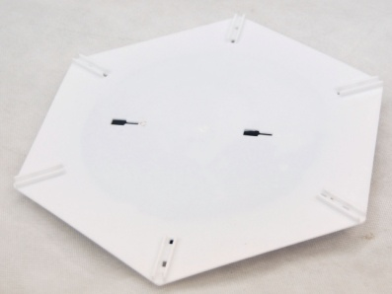
- Screw the base and the frames together
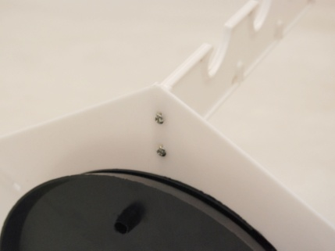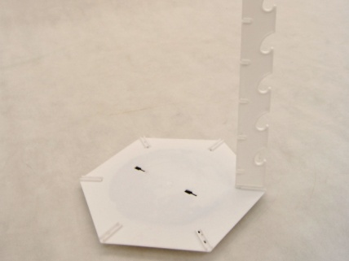
- Set up 4~5 frames first 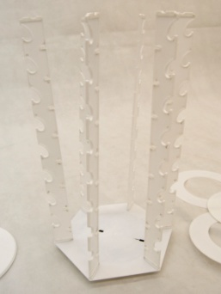 ,
- Then start to insert the plastic disks between the frames.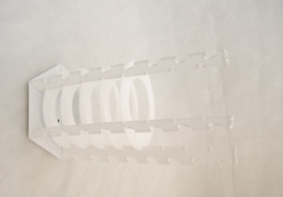5. Insert the last frame, screw the top cap, and then adjust the frames and the disks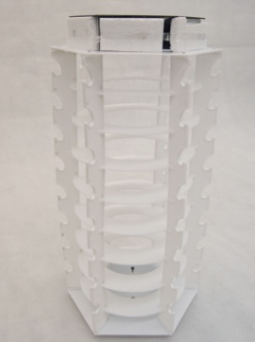
- (1 quick tip, it would be easier if you can lied it sideway when you adjust this set.)